
QUALITY ALERT

Customer: ChamClad Date: December 5, 2024
Die: 15750 Color: Any Color
Type of Complaint: ChamClad REJECT Customer NCR:

Description: ChamClad REJECT due to waving nail fin.
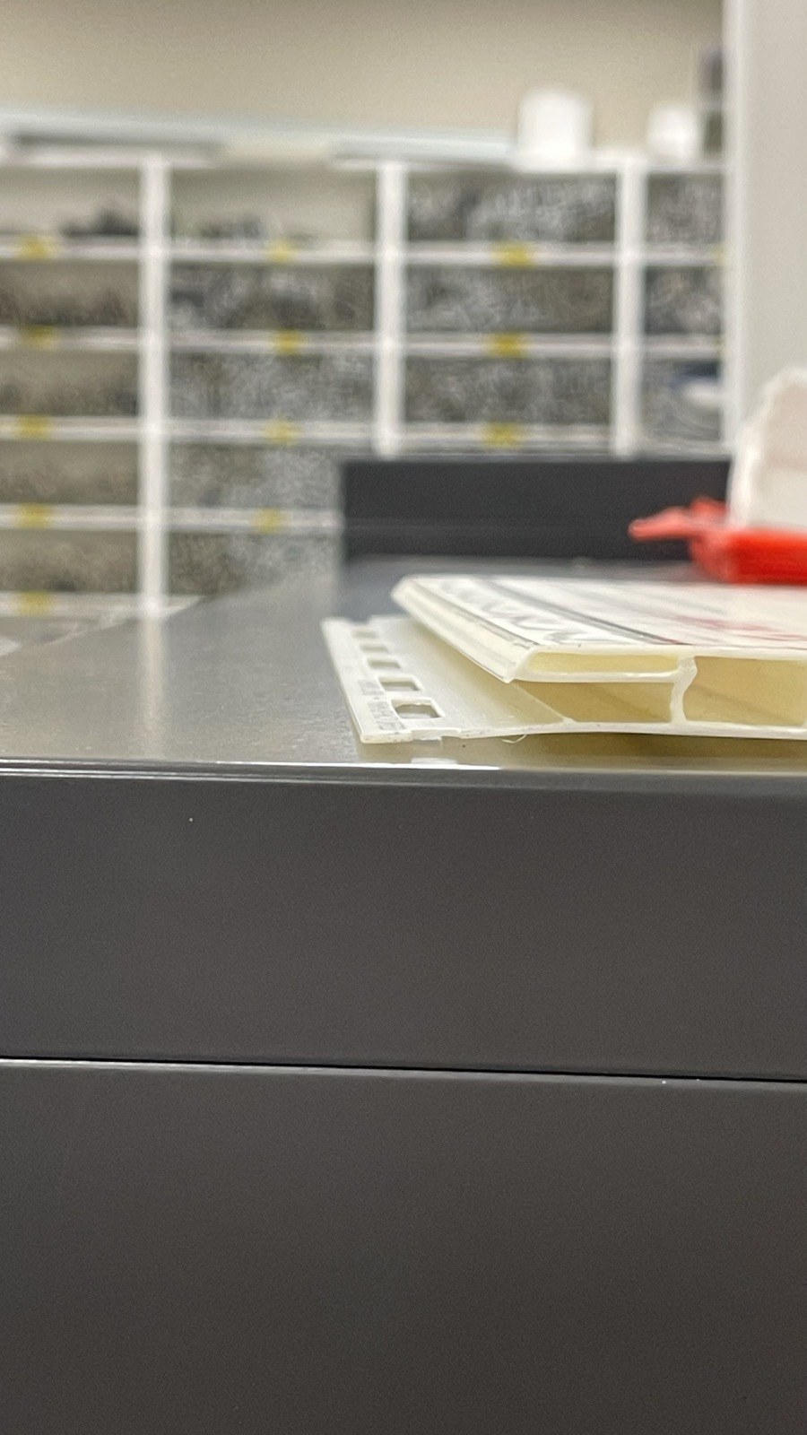
GOOD

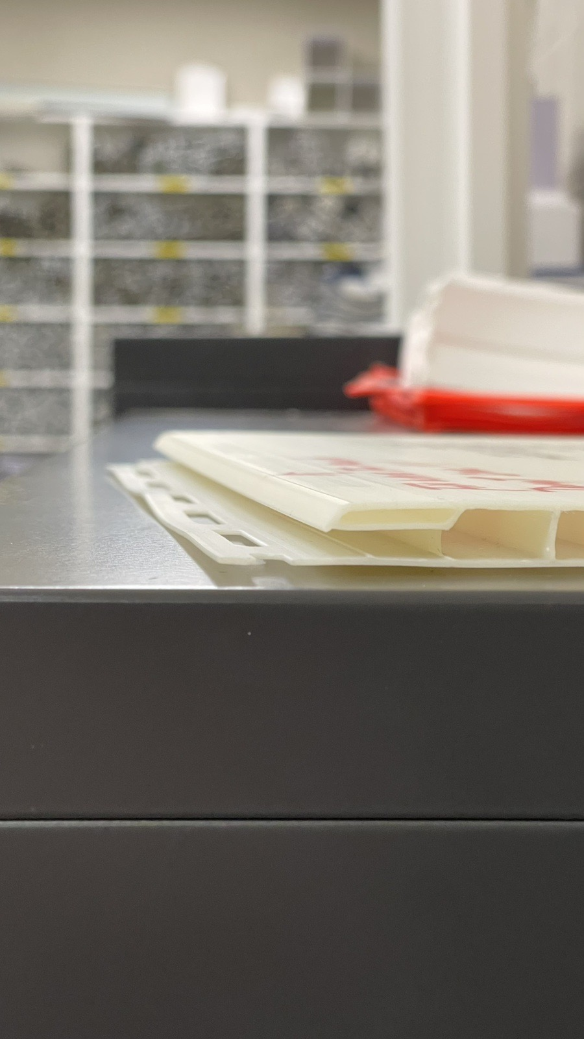
BAD

PLEASE CHECK CAREFULLY TO AVOID THIS ISSUE
BY SIGNING BELOW, YOU ACKNOWLEDGE THE PROBLEM ABOVE AND AGREE TO MONITOR THIS ISSUE IN FUTURE PRODUCTION RUNS.
DAY SHIFT |  | AFTERNOON SHIFT |  | NIGHT SHIFT
NAME | SIGNATURE | NAME | SIGNATURE | NAME | SIGNATURE

